Welcome to the
Parish Church of Holy Trinity, Blythburgh,
in the Sole Bay Team of Churches
Sunday 1 March 2020 First in Lent
Choral Evensong
Introit Nolo mortem peccatoris Thomas Morley 1577-1602
Nolo mortem peccatoris; Haec sunt verba Salvatoris.
[I do not wish the death of a sinner; These are the words of the Saviour.]
Father I am thine only Son, sent down from heav’n mankind to save.
Father, all things fulfilled and done according to thy will, I have.
Father, my will now all is this: Nolo mortem peccatoris.
Father, behold my painful smart, taken for man on ev’ry side;
Ev'n from my birth to death most tart, no kind of pain I have denied,
but suffered all, and all for this: Nolo mortem peccatoris.
Words by John Redford 1500-1547
Hymn Praise to the Holiest in the height 439
Confession and Absolution
The Lord’s Prayer (All)
Responses William Smith 1603-1645
Psalm Psalm 32
First Reading Genesis 2.15-17; 3.1-7
Hymn Be thou my guardian and my guide 64
Magnificat in D Minor by Thomas Attwood Walmisley 1814-1856
Second Reading Matthew 4.1-11
Nunc dimittis in D Minor by Thomas Attwood Walmisley 1814-1856
Creed
Responses William Smith 1603-1645
The Collect of the Day
Almighty God, whose Son Jesus Christ fasted forty days in the wilderness, and was tempted as we are, yet without sin: give us grace to discipline ourselves in obedience to your Spirit; and, as you know our weakness, so may we know your power to save; through Jesus Christ your Son our Lord, who is alive and reigns with you, in the unity of the Holy Spirit, one God, now and for ever.
The Collect for Peace
The Collect for aid against all perils
Anthem Timor et tremor Francis Poulenc 1899-1963
Timor et tremor venerunt super me et caligo cecedit super me:  Miserere mei Domine, miserere mei quoniam, in te confidit anima mea.  Exaudi Deus deprecationem meam quia refugium meum es tu  et adjutor fortis. Domine invocavi te  non confundar. | Fear and trembling come upon me, and darkness overwhelms me.  Have mercy on me O Lord,  for my soul trusts in you.  O God, hear my prayer,for  you are my refuge and my helper.  Almighty Lord, I have prayed to you that I may not be confounded.

Sermon
Prayers
Hymn O Love, how deep, how broad, how high! 425
(The offering will be taken up during this hymn)
Blessing

NOTICES
Our music is led by The Blythburgh Singers, who enjoy singing church music and who meet on the first Sunday of the month to sing Choral Evensong here. For more details, please contact Helen Hudson on 01502 511546 or flautodolce@corystes.plus.com.

Southwold Lent Lectures 2020 - Topics of public concern in our modern world
All the lectures will be at 6.00pm in the United Reformed Church, High Street, Southwold.
The Environment
1 March - The Biblical Basis
Dr Hilary Marlow, University of Cambridge
8 March - So what can I do?
Revd Sandie Barton, Suffolk Diocesan Environment Officer
Debt and Poverty
15 March - The Biblical Basis
Revd Simon Pitcher
22 March - So what can I do?
Revd Nic Stuchfield, Saxmundham: Christians Against Poverty
Disagreeing Better
29 March - Speaking the Truth in Love
Professor Hugh Williamson, University of Oxford
‘Stations on a journey’
In the run up to Easter, Blythburgh church will be displaying 15 remarkable paintings by Mark Cazalet. Shown 20 years ago in the church, as part of the Suffolk-wide millennium exhibition, Stations: the new sacred art, they follow the ‘stations of the cross’, but the events are located in intriguing urban settings, such as under the Westway A40 intersection, or in the Kilburn Station ticket hall. The exhibition opens with a reception on Saturday 28 March at 6pm. They will be on show until the morning of Monday 13 April. Artist Mark Cazalet, will be introducing the works, taking part in a number of services and leading a meditative painting workshop. See posters for more details.
Our popular café and mini-market restarts after its winter break on Friday 27 March 10.30am-12.00 noon.
The Bohemian Choir, students from the University of Liberec, in the Czech Republic, are returning for a week to Sole Bay and will hold concerts in St Peter & St Paul, Wangford (Saturday 28 March, 7pm) and Holy Trinity Blythburgh (Saturday 4 April, 7pm). Admission to the concerts is free, with a retiring collection. The choir will also sing at our Team Service in Holy Trinity Blythburgh on Passion Sunday, 29 March at 11.15am.
REGULAR SERVICES
1st Sunday 11.15am Holy Communion (Common Worship)
of the month Joint service at St Andrew’s, Walberswick
6pm Choral Evensong (BCP)
led by The Blythburgh Singers directed by Ellis Bell with organist Jonathan Palman
2nd Sunday 11.15am Holy Communion (Common Worship)
Joint service at Holy Trinity, Blythburgh
3rd Sunday 9.30am Morning Prayer (Common Worship)
4th Sunday 9.30am Holy Communion (BCP said)
5th Sunday 11am Team Service – see noticeboard for venue
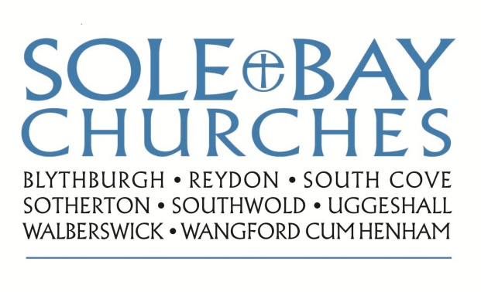
Team Rector: Revd Simon Pitcher
01502 725424 revsimon63@gmail.com
Churchwarden: Mrs Meryl Doney
01502 478229 meryldoney@me.com

