Welcome to the
Parish Church of Holy Trinity, Blythburgh,
in the Sole Bay Team of Churches
Sunday 3 November 2019 All Saints’ Day
Choral Evensong
Introit O quam gloriosum Thomàs Luis de Victoria 1548-1611
O quam gloriosum est regnum,  in quo cum Christo gaudent omnes sancti.  Amicti stolis albis,  sequuntur Agnum, quocumque ierit. | O how glorious is the kingdom wherein all the saints rejoice with Christ.  Arrayed in white apparel they follow the Lamb wherever  he goes.
A traditional antiphon based on words from Revelation
Hymn The Church’s one foundation 484
Confession and Absolution
The Lord’s Prayer (All)
Responses Matthew Wood b1972
Psalm Psalm 149
First Reading Daniel 7.1-3,15-18
Hymn Immortal, invisible, God only wise 377
Magnificat in B♭ by Charles Villiers Stanford
Second Reading Luke 6.20-31
Nunc dimittis in B♭ by Charles Villiers Stanford
Creed
Responses Matthew Wood b1972
The Collect of the Day
Almighty God, you have knit together your elect in one communion and fellowship in the mystical body of your Son Christ our Lord: grant us grace so to follow your blessed saints in all virtuous and godly living that we may come to those inexpressible joys that you have prepared for those who truly love you; through Jesus Christ your Son our Lord, who is alive and reigns with you, in the unity of the Holy Spirit, one God, now and for ever.
The Collect for Peace
The Collect for aid against all perils
Anthem Te deum Charles Villiers Stanford 1852-1924
We praise thee, O God : we acknowledge thee to be the Lord.
All the earth doth worship thee : the Father everlasting.
To thee all Angels cry aloud : the Heavens, and all the Powers therein.
To thee Cherubim and Seraphim : continually do cry,
Holy, Holy, Holy : Lord God of Sabaoth;
Heaven and earth are full of the Majesty : of thy glory.
The glorious company of the Apostles : praise thee.
The goodly fellowship of the Prophets : praise thee.
The noble army of Martyrs : praise thee.
The holy Church throughout all the world : doth acknowledge thee;
The Father : of an infinite Majesty; Thine honourable, true : and only Son;
Also the Holy Ghost : the Comforter.Thou art the King of Glory : O Christ.
Thou art the everlasting Son : of the Father.
When thou tookest upon thee to deliver man :
thou didst not abhor the Virgin's womb.
When thou hadst overcome the sharpness of death :
thou didst open the Kingdom of Heaven to all believers.
Thou sittest at the right hand of God : in the glory of the Father.
We believe that thou shalt come : to be our Judge.
We therefore pray thee, help thy servants :
whom thou hast redeemed with thy precious blood.
Make them to be numbered with thy Saints : in glory everlasting.
O Lord, save thy people : and bless thine heritage.
Govern them : and lift them up for ever. Day by day : we magnify thee;
And we worship thy Name : ever world without end.
Vouchsafe, O Lord : to keep us this day without sin.
O Lord, have mercy upon us : have mercy upon us.
O Lord, let thy mercy lighten upon us : as our trust is in thee.
O Lord, in thee have I trusted : let me never be confounded.
Words from a 4th century Latin Christian Hymn
Sermon
Prayers
Hymn Dear Lord and Father of mankind 353
(The offering will be taken up during this hymn)
Blessing

NOTICES
Our music is led by The Blythburgh Singers, who enjoy singing church music and who meet on the first Sunday of the month to sing Choral Evensong here. For more details, please contact Helen Hudson on 01502 511546 or flautodolce@corystes.plus.com.
Remembrance in Blythburgh – our joint Service will take place at 10.50am next Sunday, 10 November, at St Andrew’s, Walberswick.
Sunday 1 December at 6pm - the Blythburgh Singers will lead an Advent Carol Service, which will take the place of our usual Choral Evensong.
Memorial service for Archdeacon Ian Morgan will take place on Sunday 17 November at Holy Trinity, Blythburgh at 3pm. If you are intending to come, please car share if possible.
Sunday 24 November 4pm Holy Trinity: Anam Cora present “Arriving Home’’. As the nights close in, and Anam Cora’s pilgrimage through the cycle of the year draws to a close, these five singers reflect on the seasons they have travelled through, and weave together song, poetry and silence into this Sung Meditation. Come and join them! No booking required. Donations invited - £10 suggested. This event will be raising funds for the charity Combat Stress. For more information on Anam Cora visit www.marybenefiel.com/anam-cora/
Holy Trinity’s annual Christmas Market will take place in the church on Saturday 30 November from noon to 4pm. Over 30 stalls selling local crafts, food and drink, Christmas cards and decorations, plus home-made soups, mulled wine, mince-pies and cakes to fortify you for your Christmas shopping!
Christmas cards featuring a painting of the Church in the snow by local artist, Mary Gundry, are now on sale on the bookstall at £5 for a pack of five. All proceeds to the Friends of Holy Trinity. Please contact Jenny Allen if you would like to place a bulk order - 01502 478314.
Advance notice - Christmas at Holy Trinity
Sunday 22 December | 4pm | Lessons and Carols by candlelight, led by the Blythburgh Singers
Tuesday 24 December | 5pm | Crib Service
Tuesday 24 December | 11.30pm | Midnight Communion
Wednesday 25 December | 10am | Family Service

REGULAR SERVICES
1st Sunday 11.15am Holy Communion (Common Worship)
of the month Joint service at St Andrew’s, Walberswick
6pm Choral Evensong (BCP)
led by The Blythburgh Singers directed by Ellis Bell with organist Jonathan Palman
2nd Sunday 11.15am Holy Communion (Common Worship)
Joint service at Holy Trinity, Blythburgh
3rd Sunday 9.30am Morning Prayer (Common Worship)
4th Sunday 9.30am Holy Communion (BCP said)
5th Sunday 11am Team Service – see noticeboard for venue
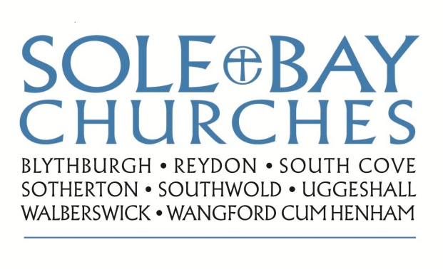
Team Rector: Revd Simon Pitcher
01502 725424 revsimon63@gmail.com
Churchwarden: Mrs Meryl Doney
01502 478229 meryldoney@me.com

