Welcome to the
Parish Church of Holy Trinity, Blythburgh,
in the Sole Bay Team of Churches
Sunday 7 July 2019 Third after Trinity
Choral Evensong

Introit A Gaelic Blessing John Rutter b1945
Deep peace of the running wave to you,
Deep peace of the flowing air to you,
Deep peace of the quiet earth to you,
Deep peace of the shining stars to you,
Deep peace of the gentle night to you,
Moon and stars pour their healing light on you,
Deep peace of Christ, the light of the world to you.
Words adapted from an old Gaelic rune
Hymn O worship the Lord in the beauty of holiness! 52
Confession and Absolution
The Lord’s Prayer (All)
Responses Ellis Bell
Psalm Psalm 66 vv1-8
First Reading Isaiah 66.10-14
Hymn Rock of ages, cleft for me 445
Magnificat Herbert Howells 1892-1983
Second Reading Luke 10.1-11,16-20
Nunc dimittis Herbert Howells 1892-1983
Creed
Responses Ellis Bell
The Collect of the Day
Almighty God, you have broken the tyranny of sin and have sent the Spirit of your Son into our hearts whereby we call you Father: give us grace to dedicate our freedom to your service, that we and all creation may be brought to the glorious liberty of the children of God; through Jesus Christ your Son our Lord, who is alive and reigns with you, in the unity of the Holy Spirit, one God, now and for ever.
The Collect for Peace
The Collect for aid against all perils
Anthem O, pray for the peace of Jerusalem
Herbert Howells 1892-1983
O pray for the peace of Jerusalem. They shall prosper that love thee.
Peace be within thy walls and plenteousness within thy palaces.
Words from Psalm 122: Vv 6-7

Sermon
Prayers
Hymn O Jesus, I have promised 420
(The offering will be taken up during this hymn)
Blessing

NOTICES
Our music is led by The Blythburgh Singers, who enjoy singing church music and who meet on the first Sunday of the month to sing Choral Evensong here. For more details, please contact Helen Hudson on 01502 511546 or flautodolce@corystes.plus.com.

Our monthly café and Mini-market continues to go from strength to strength. Join the gathered throng on Friday 26 July from 10.30am, til noon.
Revd Malcolm Doney will help launch the proceedings for the village’s annual Blythburgh Day on Sunday 4 August by leading an open air service in the 12th century ruins of the priory at 11am.
In collaboration with Blythburgh Day, there’ll be a first ever attraction in the church: The Blythburgh Summer Exhibition. Subtitled “a celebration of a creative village,” this will be a display of creative work by resident talent: from paintings to pots, from sculpture to sewing, and much beside. There’ll be an opening party on Friday 2 August from 6pm, and the show will be open on Saturday and Sunday. Entrance is free.
Our hugely popular service for the Blessing of Animals will take place on Sunday 18 August at 11am. All creatures great and small welcome.
Sole Bay Team Ladies Fellowship meets every Wednesday at 2pm in the church room at St Margaret’s Church, Reydon, for informal bible study, praise and prayer, friendship and fellowship, and tea and biscuits. All ladies are welcome! We are hosting tea and cake on Wednesday 10 July at 2pm and we would love it if you could come along. For more information please contact Suzzie Godfrey on 07539 5137530
South Cove Flower Festival and Exhibition, Friday 26 July to Tuesday 30 July – Opens with a ticketed Preview Evening 6pm-8pm. Tickets are £5 (include wine, soft drinks and nibbles), and are available from Revd Alan Perry 453624, Alison Evans 675610. There will be a tapestry of floral displays and an exhibition in church of ‘all things South Cove’. In place of the Meadow Sale, there will be a large Book Sale, a Plant Stall and a Preserve Stall in the marquee. The renowned homemade refreshments, including a range of full cream dairy ice-creams, will be available daily. On Sunday evening 28 July at 7pm Yalda Davis has very kindly agreed to give a ’cello recital in church. Refreshments will be served from 6.30pm onwards with a Retiring Collection at the end of the evening.
50th Anniversary of Uggeshall Teas, the last weekend of July and the first weekend of August.
REGULAR SERVICES
1st Sunday 11.15am Holy Communion (Common Worship)
of the month Joint service at St Andrew’s, Walberswick
6pm Choral Evensong (BCP)
led by The Blythburgh Singers directed by Ellis Bell with organist Jonathan Palman
2nd Sunday 11.15am Holy Communion (Common Worship)
Joint service at Holy Trinity, Blythburgh
3rd Sunday 9.30am Morning Prayer (Common Worship)
4th Sunday 9.30am Holy Communion (BCP said)
5th Sunday 11am Team Service – see noticeboard for venue
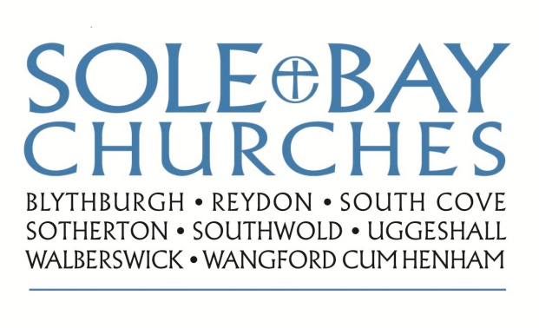
Team Rector: Revd Simon Pitcher
01502 725424 revsimon63@gmail.com
Churchwarden: Mrs Meryl Doney
01502 478229 meryldoney@me.com

