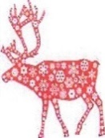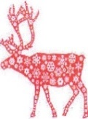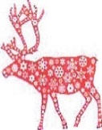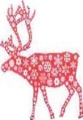

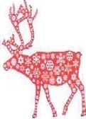 CHRISTMAS  
 MARKET

**SATURDAY   
30th NOVEMBER**

# **11am to 3.30pm**

**HOLY TRINITY CHURCH**

**BLYTHBURGH**

## **GIFTS, CRAFTS, ETC. HOME MADE SOUPS, MULLED WINE, CAKES, TEA / COFFEE, ETC.**